EASTERN REGIONAL INTERSTATE
CHILD SUPPORT ASSOCIATION
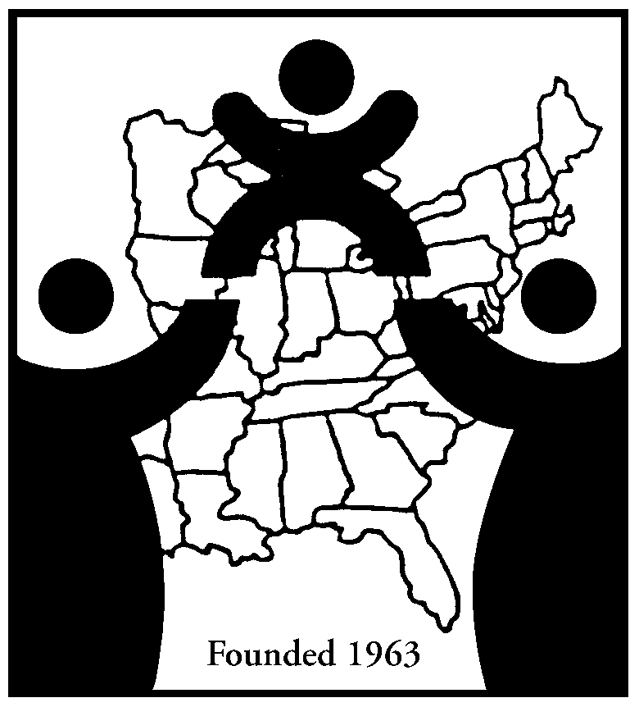

OFFICERS

ROBERT VELCOFF, President
40 N. Pearl St., 13th Floor, Albany, NY 12243

SUSAN SCHROEDER, President Elect
602 S. Calhoun St., Fort Wayne, IN 46802

COESSA KENNEY,
Vice President of Conference Operations
161 E. Michigan Ave. Battle Creek, MI 49014

CHRISTINE JENNINGS,
Vice President of Policy & Legislation
3975 Virginia Mallory Dr., Chantilly, VA 20151

CARLA WEST
Vice President of Exhibitors & Sponsors
401 S. Griffin St., Ste. 350
Elizabeth City, NC 27909

LARA FORS, Secretary
313 South Ave, Ste 300, Springfield MO 65806

BOB FISLER, Treasurer
204 Rhoads Ave., Haddonfield, NJ 08033

ELAINE POOLE, Immediate Past President
274 Triple Oaks Dr., Tucker, GA 30084

BOARD OF DIRECTORS

MARGOT BEAN 2010-2012
2221 Stoneridge Rd, Niskayuna, NY 12309

JIM DINGELDINE 2011-2013
1628 Browning Rd., Suite 100
Columbia, SC 29210

KATHY DVORAK 2011-2013
227 W. Jefferson Blvd, 6th Fl,
South Bend, IN 46601

DEBORAH EDWARDS 2011-2013
13031 Park Crescent Circle, Herndon VA 20171

LINDA HUDSON 2010-2012
203 Boca Shores Dr., Panama City, FL 32408

GINA JONES 2010-2012
400 Broadway, Rm 107, Gary, IN 46402

TIM McCLAIN 2010-2012
PO Box 2150, Frankfort, KY 40602-2150

GWEN NEELY 2011-2013
2201 Darien Pl, Wilson NC 27896

TERRI NICKEL 2011-2013
624 Baldwin Ave., Norfolk, VA 23517

PATRICK QUINN 2012-2012
440 Ross St., 5th Fl., Pittsburgh, PA 15219

PAM SALA 2011-2013
230 Elizabeth Lake Rd., Pontiac, MI 48341

CHRISTIN SEMPREBON 2011-2013
100 Mineral St., Ste. 202, Springfield VT 05156

PATTI SPEAR 2011-2013
149 Dawn Lauren Lane, Tallahassee, FL 32301

RHONDA TAMULONIS 2011-2013
9225 Priority Way West Dr.
Indianapolis, IN 46240

HONORARY BOARD MEMBERS

DIANE JORDAN
903 Enterprise Blvd. Ste 110
Hampton, VA 23666

ROBYN LARGE
1075 Piccadilly Lane, Rock Hill, SC 29732

CYNTHIA LUCAS
3880 Croydon Dr. NW, Canton, OH 44718

SARA MCCOLLUM
1 Federal St. Bldg 103-2, Springfield, MA 01105

PATTERSON POULSON,
5050 W Tennessee St, Tallahassee, FL 32399

December 2, 2011

TO: NCCSD

RE: Lewin Report, Part 2

Madam President:

As President of the Eastern Regional Interstate Child Support Association (ERICSA), I am notifying you that we no longer have any financial responsibility for the Lewin Report, Part 2. As specified in our MOU, ERICSA was to receive the report for review and comment before its finalization. It has been over four and a half years since we entered into this MOU, and after numerous inquiries we still have not received a copy of the report. We have removed this item from our budget.

Please let me know if you have any questions about this. Thank you.

Sincerely,

Robert Velcoff, President
ERICSA

